HADOOP

- Data Ingestion:
- Create a directory in HDFS and transfer the banking dataset from the local system to the HDFS directory.
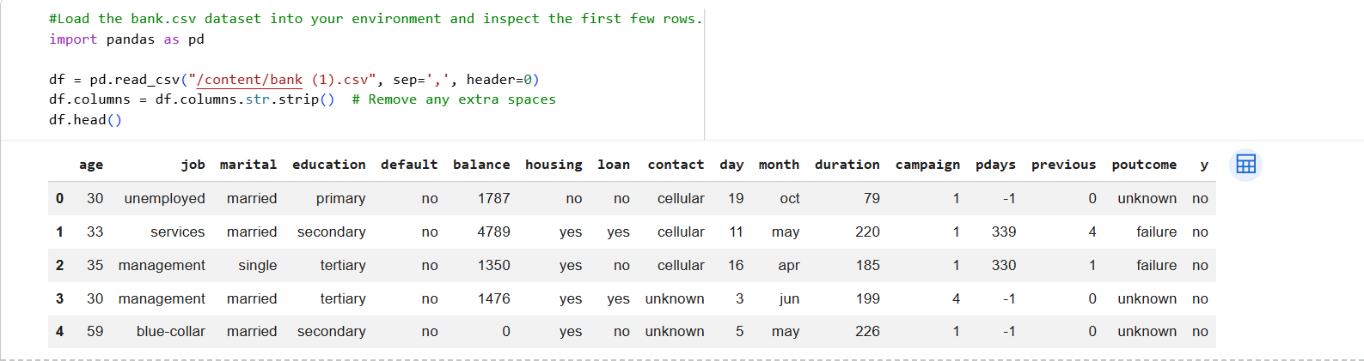
- Data Transformation with MapReduce:
- Write a MapReduce program in Python that calculates the average account balance for each job type.
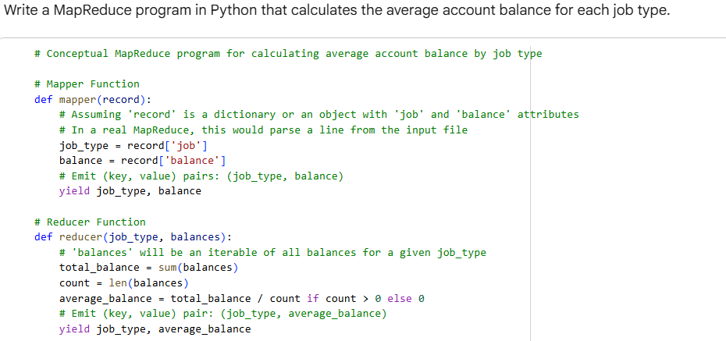
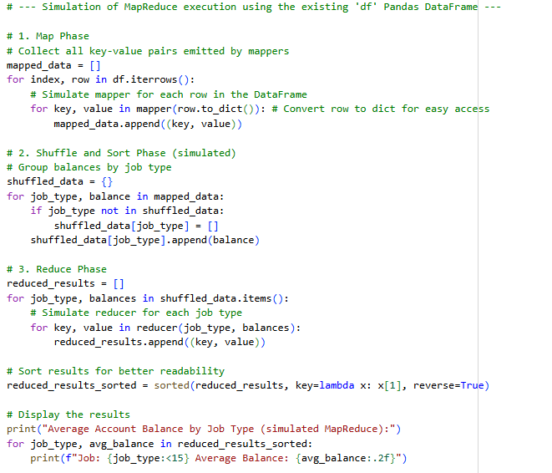

Output
: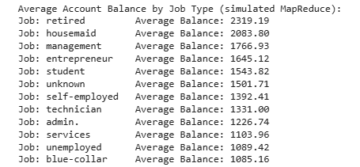
- Write another MapReduce program that counts the number of individuals with and without a housing loan in each education category.
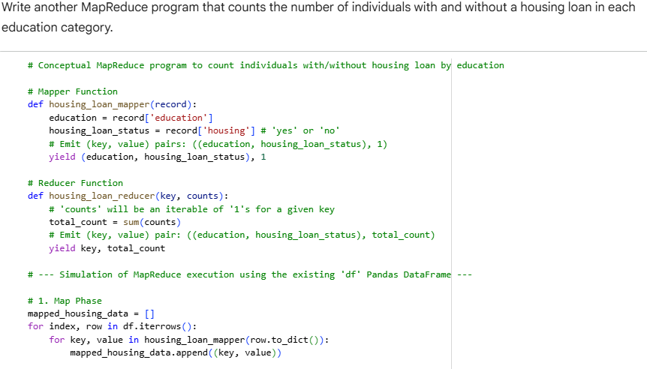
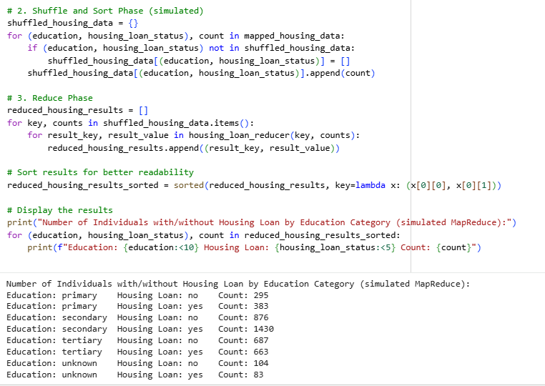
- Perform a MapReduce job to determine the number of clients contacted in each month and their subscription status to term deposits ('y' column).
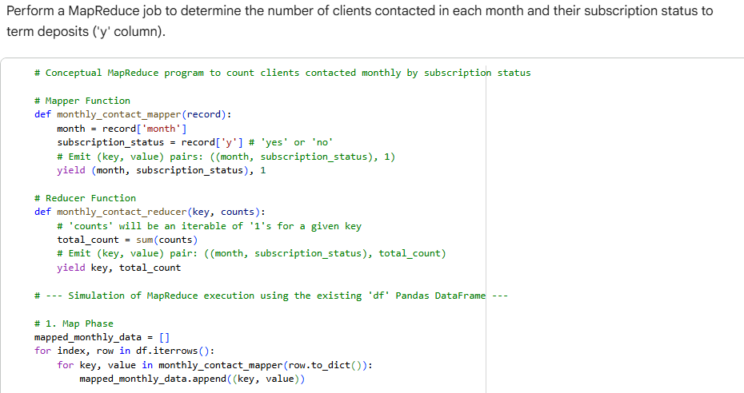
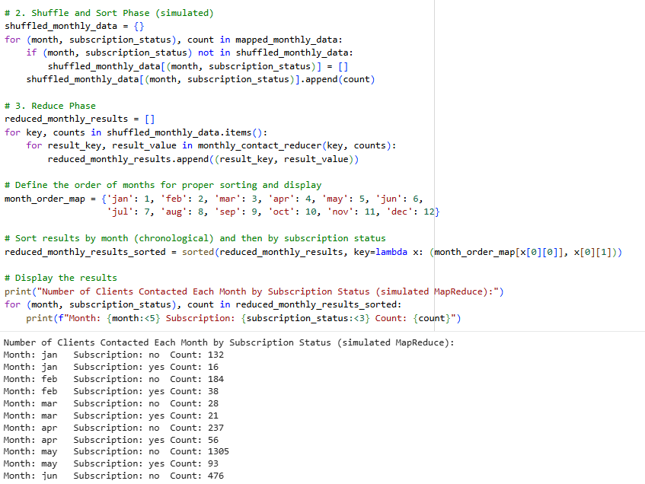
- Data Analysis with MapReduce:
- Analyze the average duration of contact (in seconds) per campaign outcome ('poutcome').
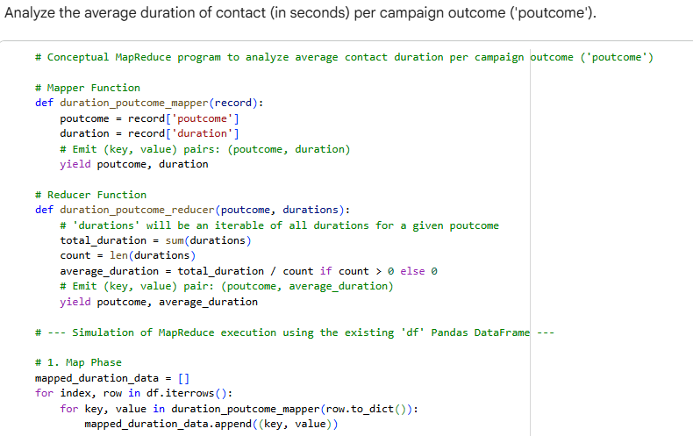
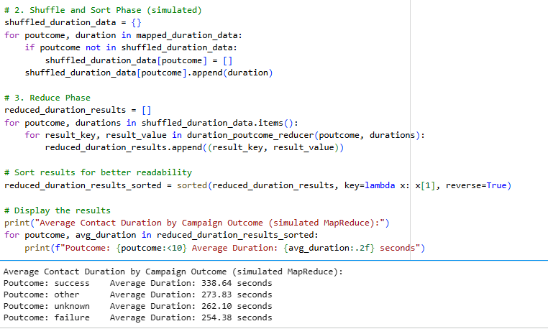
- Examine the relationship between the age of clients and their balance, and present findings in a summarized form.
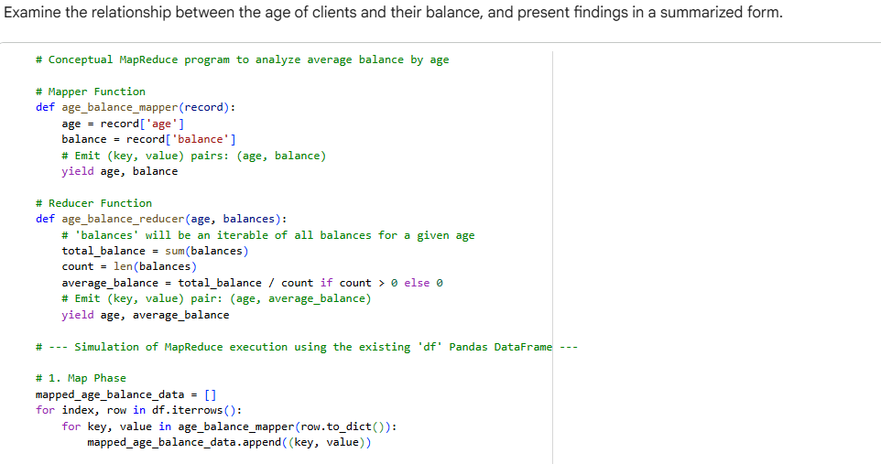
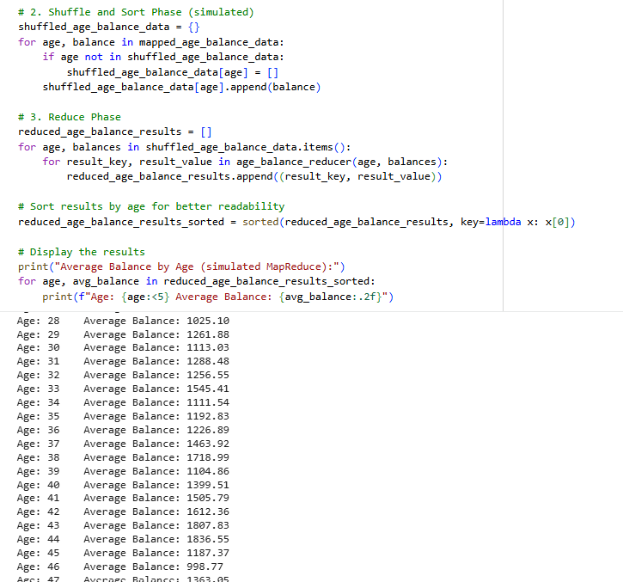

HIVE
- Data Ingestion and Table Creation:
  - Create a Hive database named banking_data.
  - Define and create a Hive table client_info with appropriate data types for the bank.csv dataset.
  - Load the data from the bank.csv file into the client_info table.
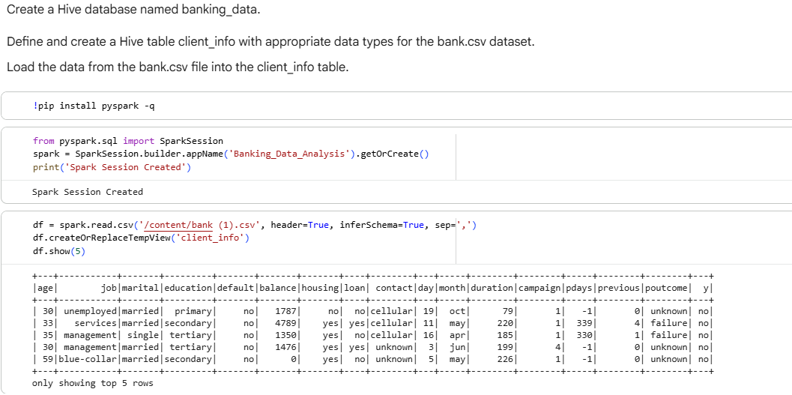
- Basic Data Exploration:
  - Write a HiveQL query to count the total number of clients in the dataset.
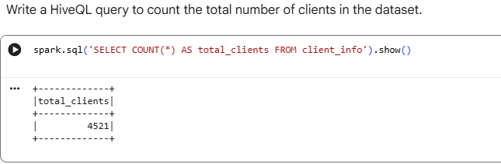
  - Display the first 10 rows of the dataset.
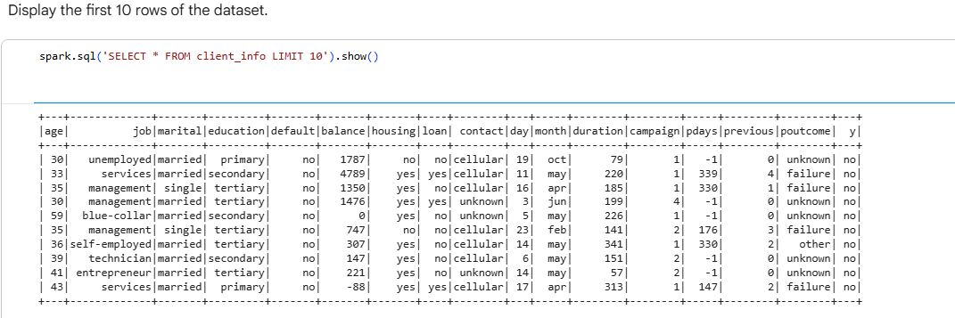
- Data Filtering and Sorting:
  - Retrieve all records of clients who are married and have a personal loan.
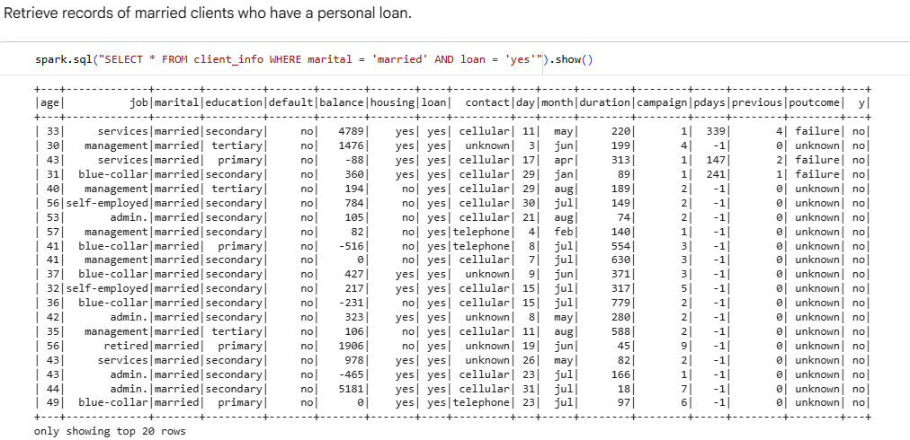
  - List the top 10 clients with the highest balance, displaying their job, marital status, and balance.
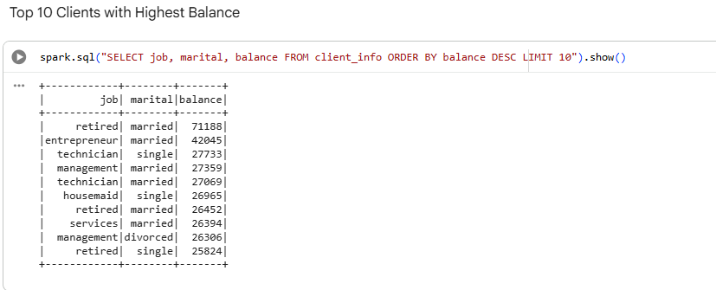
- Data Aggregation and Grouping:
  - Calculate the average age of clients for each job category.
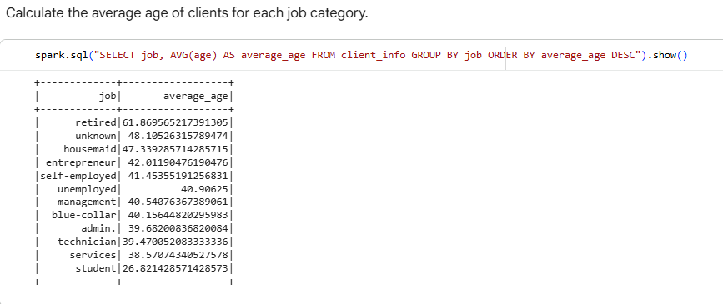
  - Find the total number of clients for each education level who have defaulted on credit.
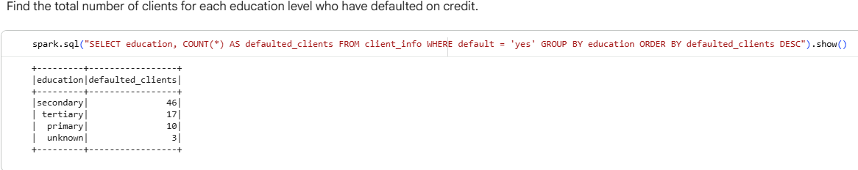
- Complex Queries for Insights:
  - Identify the top 5 job categories with the highest average balance and the percentage of clients in each of these job categories who have subscribed to a term deposit.
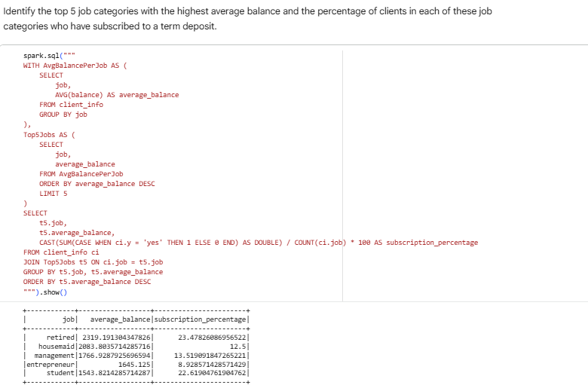

  - Determine the month with the highest number of contacts and the success rate of the campaign in that month (percentage of clients who subscribed to a term deposit).
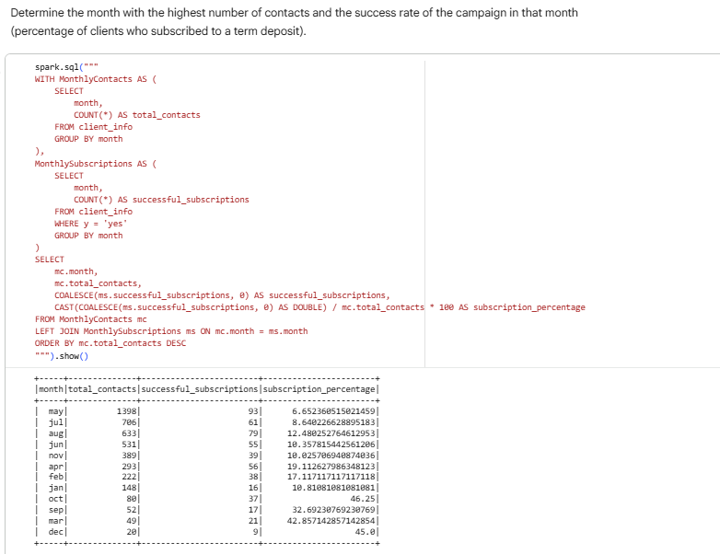
- Correlation Analysis:
  - Calculate the correlation between age and balance for the clients.
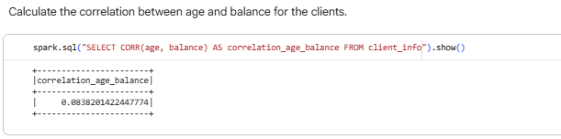

- Trend Analysis:
  - Analyze the year-over-year trend in the number of clients contacted.
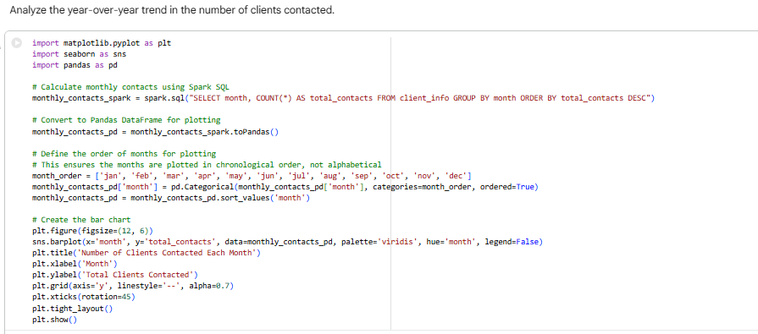
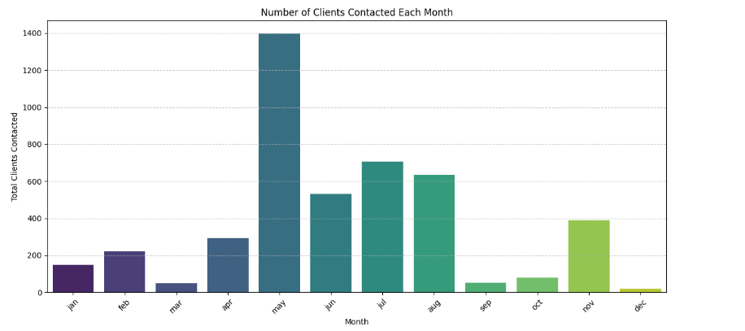
- Anomaly Detection:
  - Identify any unusual patterns in the average yearly balance across different education levels.
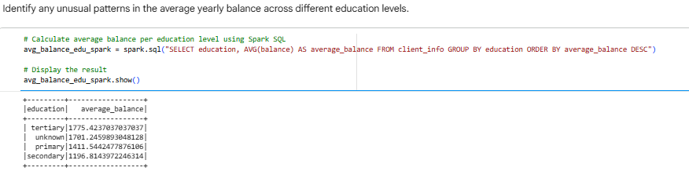

- Advanced Analysis:
  - Analyze the impact of previous campaign outcomes (poutcome) on the current campaign's success. Calculate the subscription rate (to term deposits) for each poutcome category.
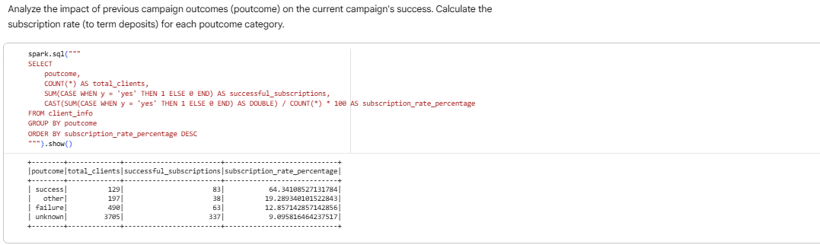
  - Compare the average contact duration for clients who subscribed and who did not subscribe to a term deposit.
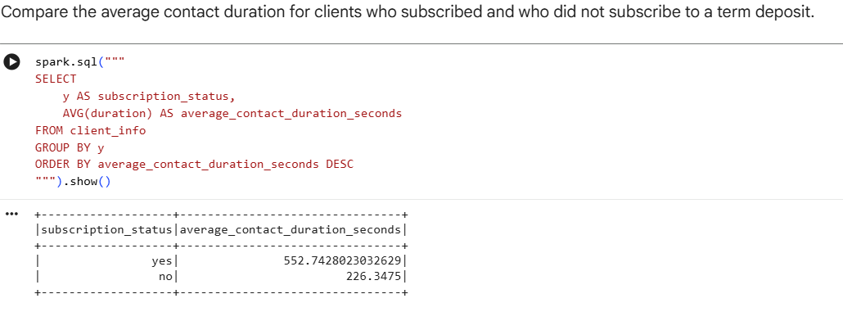
DRIVE LINK : https://drive.google.com/drive/folders/1lv1MivgxVPQHjG78N2A_v2d2VKHM4Kvg?usp=sharing
Submission Guidelines:
- Make a copy of this doc file.
- Perform the analysis in your local system using Hadoop and Hive and provide screenshots of both the code and the output under each question.
- Upload the doc file with other files and submit it in the submission dashboard.

